CSE 3033 OPERATING SYSTEMS PROJECT #2 REPORT
BASIC SHELL WITH C

Mustafa Abdullah Hakkoz – 150117509
Enes Garip – 150116034

Subject of the Project
In this project, the objective is implementing a basic shell program with C. The basic shell program including some of these functions
- Takes command from the user as input and execute the command in a new process so shell program runs continuously until user enters ^D (<CTRL><D>).
- Runs commands in background when user appends “&” to end of input.
- Supports internal commands such as
“history” : Shows last 10 commands that user enters.
“history -i %num” : Executes the code in index %num
^z signal : Stops currently running foreground process.
“path” : Shows current paths.
“path” :
“path + /foo/bar” : Appends /foo/bar to current paths.
“path - /foo/bar” : Removes /foo/bar from current paths.
“fg %num” : Move background process with id %num to foreground.
“exit” : Terminates shell if there’s no background process.

- The shell program also supports I/O Redirection such as:
“myprog [args] > file.out”
“myprog [args] >> file.out”
“myprog [args] < file.in”
“myprog [args] 2> file.out”
“myprog [args] < file.in > file.out”

PART A

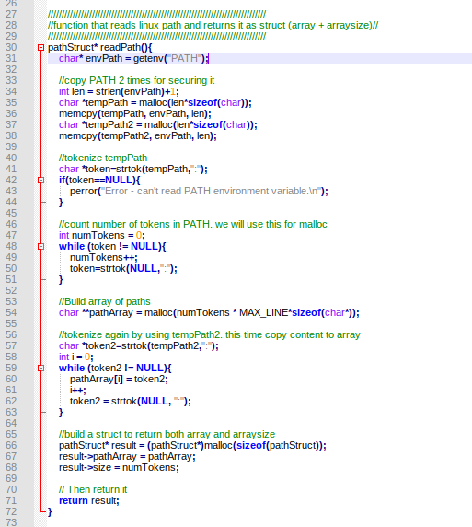

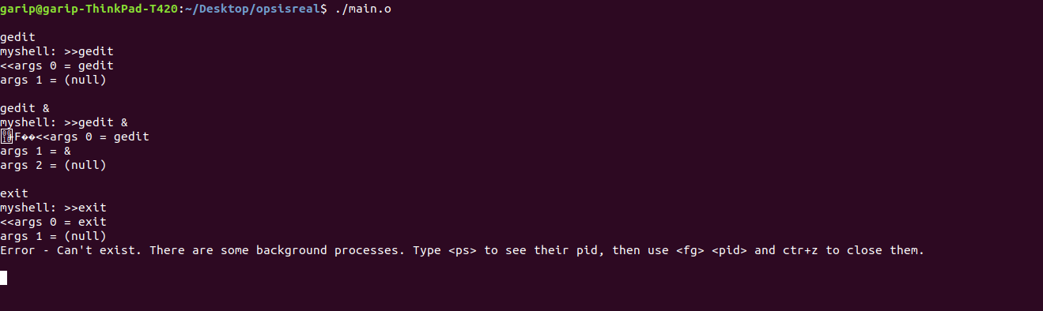
PART B

Path command to add or remove paths.

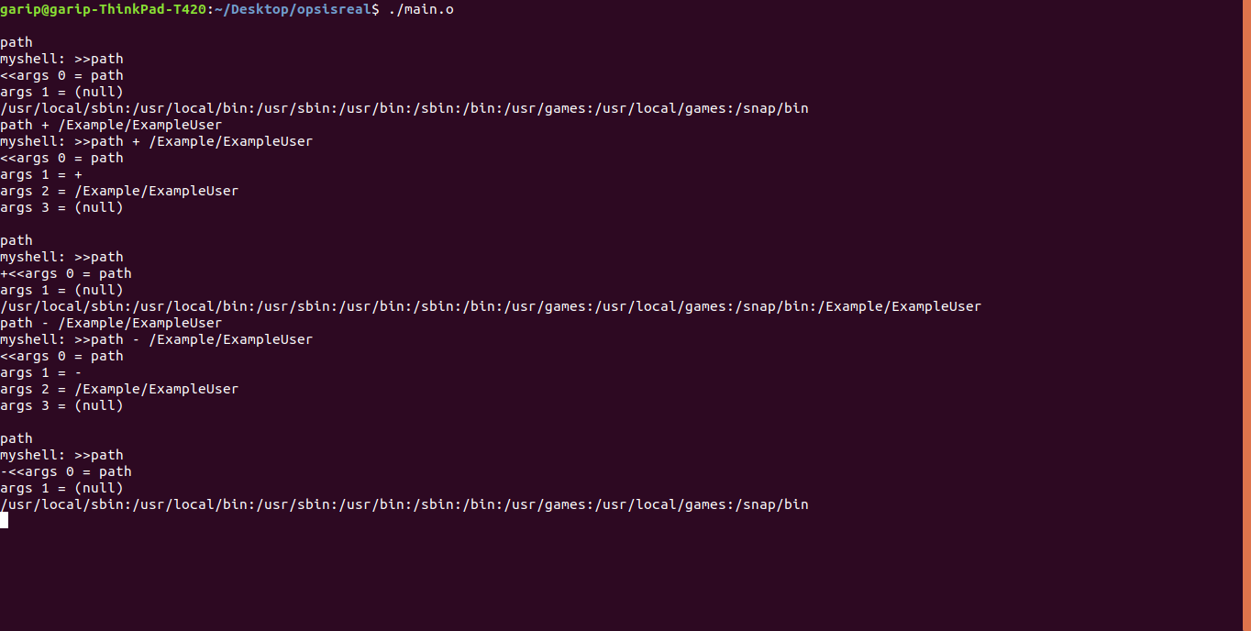
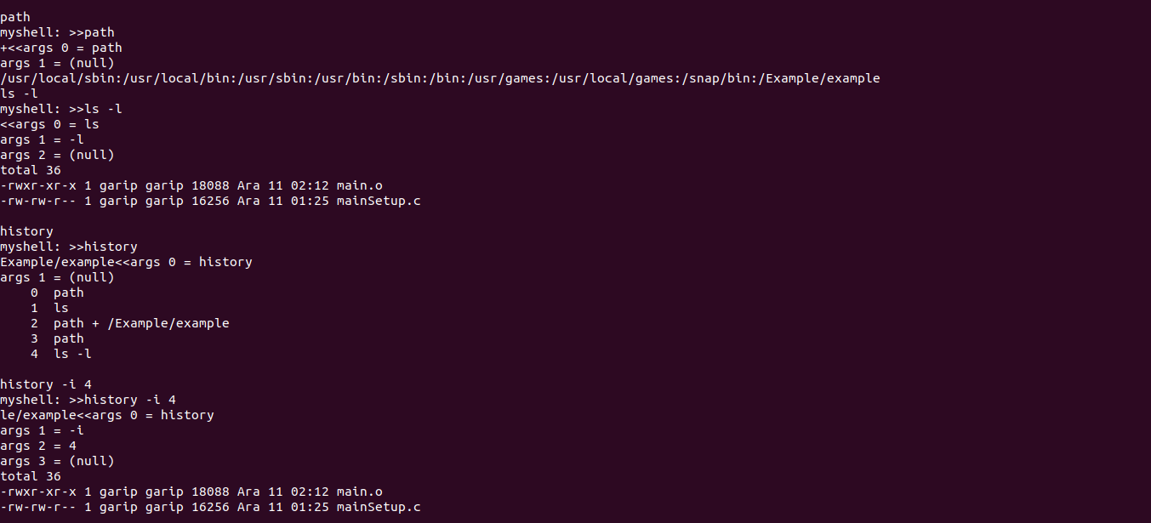
History command for command history.

<CTRL><Z> Function
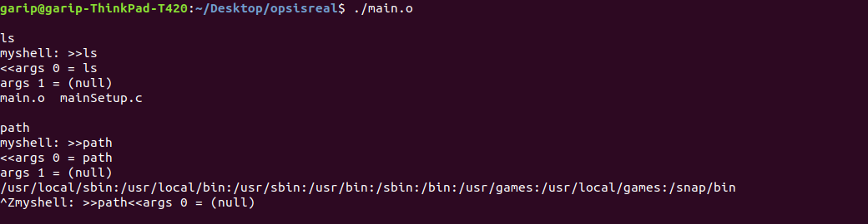
PART C

